**Creating a virtual Vm.**

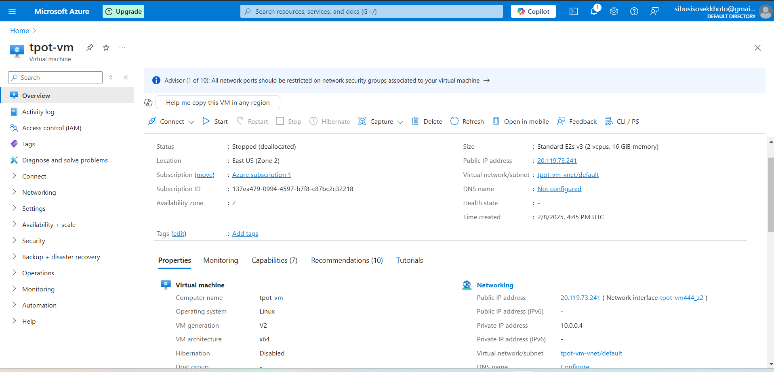Here we have a virtual machine running on azure.

And the specs are as follows:

* Name- Tpot-vm
* Region – East US available on Zone 2
* Security Type – Standard
* The we t create/select an image we are going to use for our virtual machine in this case I have an Ubuntu Minimal 24.04 LTS –x64 Gen2
* And our virtual machine size is Standard E2s V3 (2 Cups, 16Gib memory)
* Vm Architecture x64

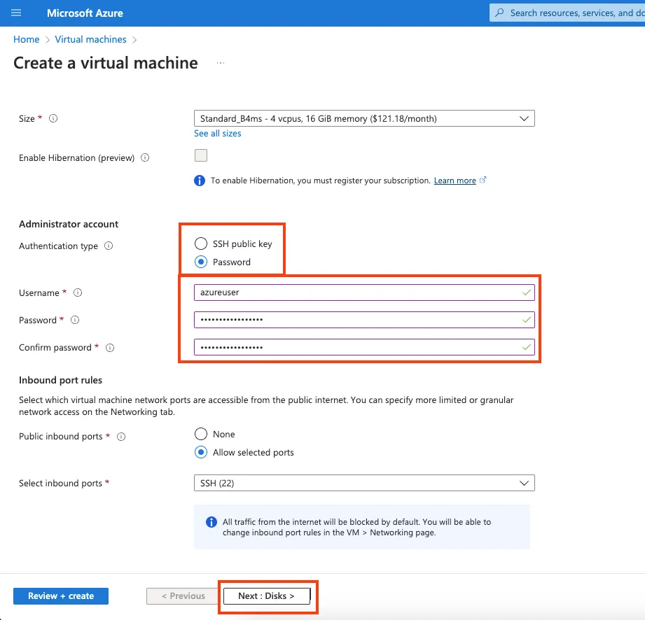

* Select password authentication type
* Choose username ‘azure’and enter your passsword

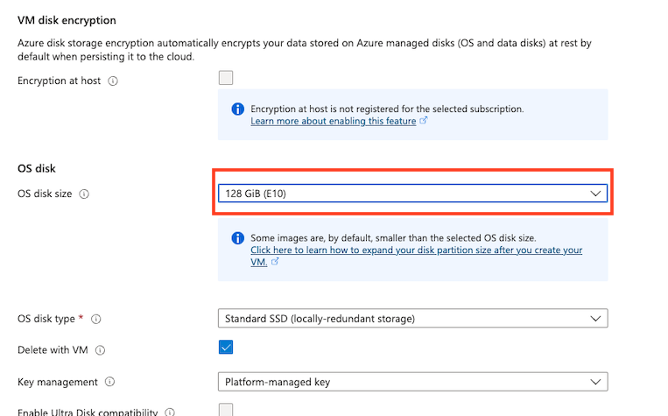

* Change the bo to delete public IP and NIC when VM is deleted

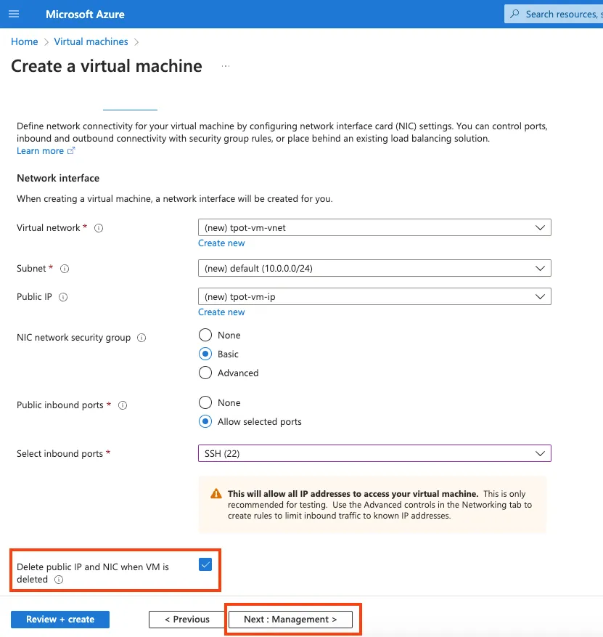

* Click review + create at the top
* 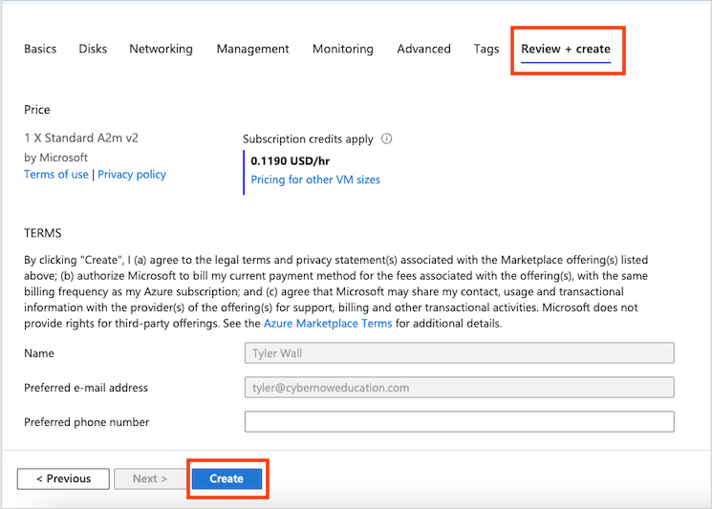
* **Figure 1–8** Click Review and Create and then Create
* Wait for your VM deployment to finish
* 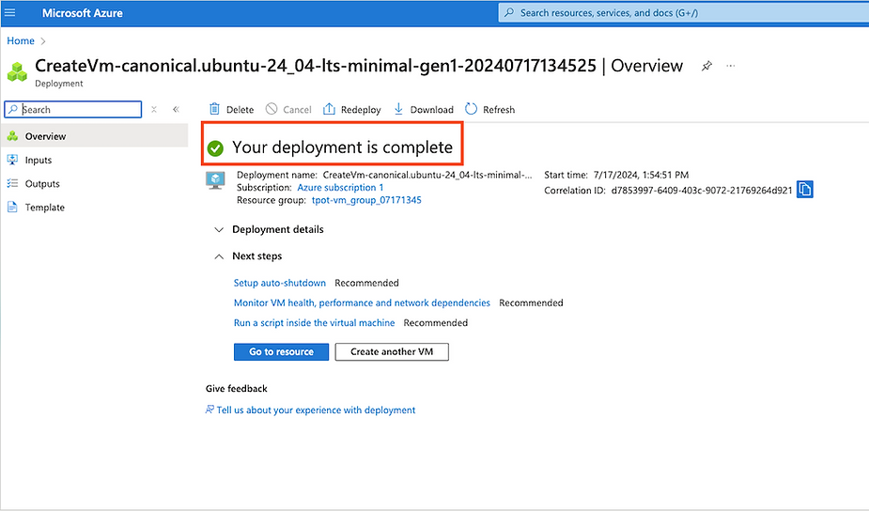
* **Figure 1–9** Deployment Finished

# Open Traffic Flow

* Now we need to open up the gates and create a rule to allow all communication in to the honeypot. This will allow the adversaries to be able to attack the honeypot so you can collect the data.
* At the top search bar, type in “tpot-vm-nsg” and select the network security group resource
* 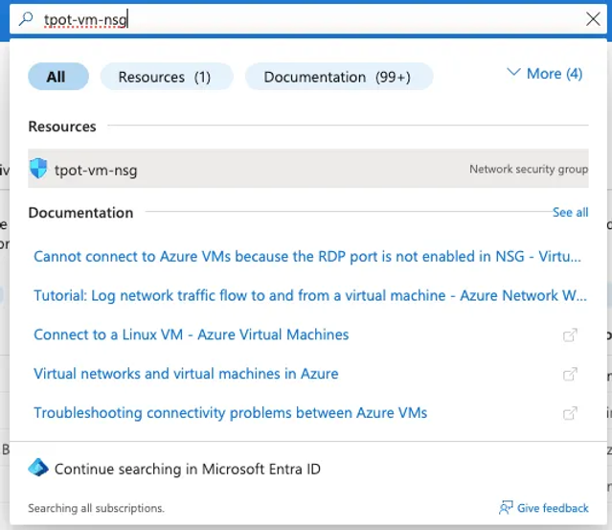
* **Figure 2–1** Select the Network Security Group We Created
* Select “Inbound security rules” on the left
* 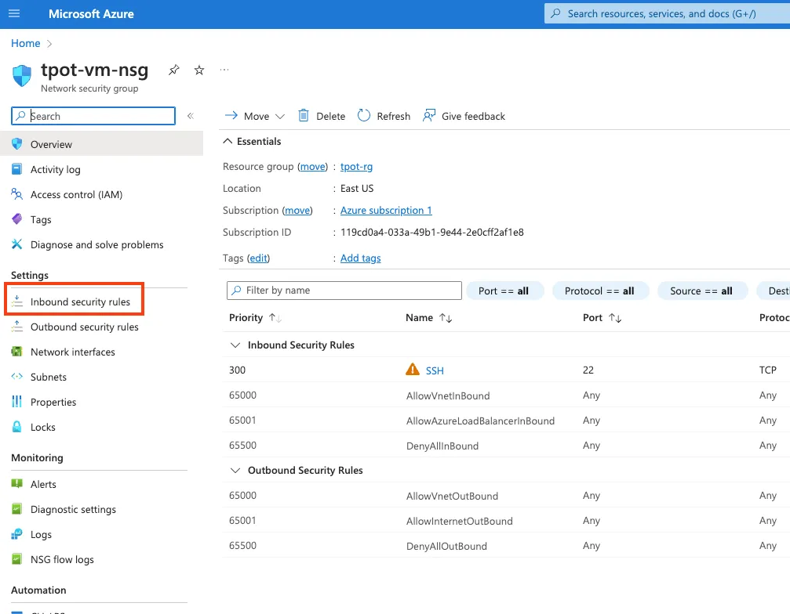
* **Figure 2–2** Select Inbound Security Rules
* Click “Add”
* 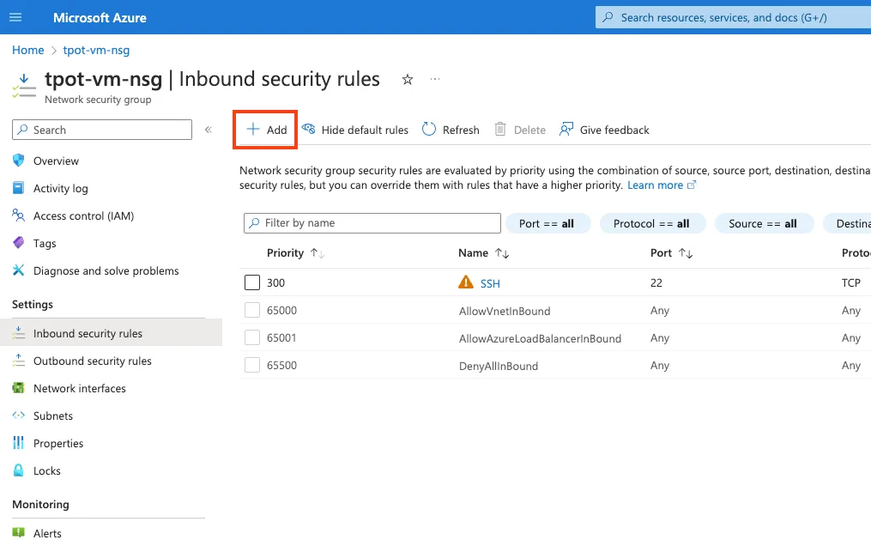
* **Figure 2–3** Click Add
* Change Destination port ranges to start “*”
* Change Priority to “100”
* Change Name to “DANGER_ALLOW_ALL”
* Click “Add”
* This rule on the Network Security Group applies to all resources in the network security group and allows ALL traffic on ALL ports inside. This is not recommended anywhere at anytime except right now.
* 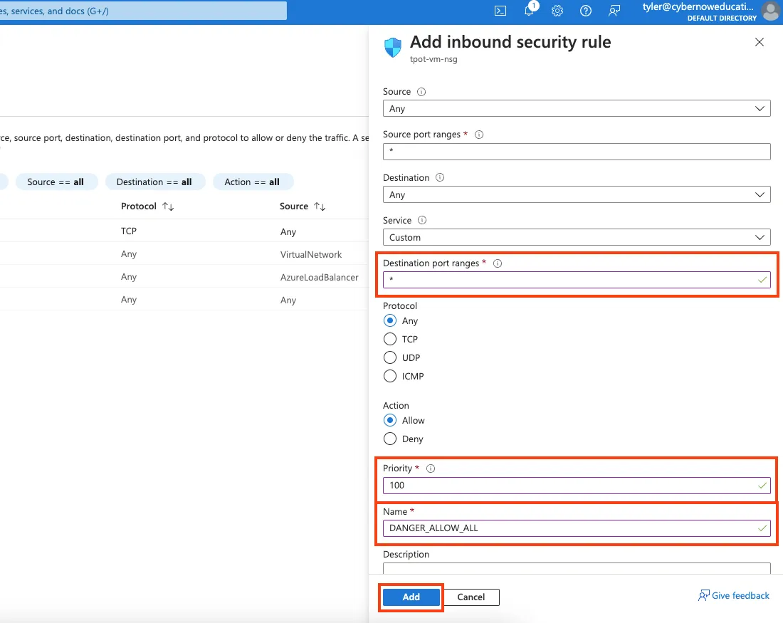
* **Figure 2–4** Change Destination Port Range, Priority, and Name then Click Add

# Configuring the honeypot

* Now we need to go grab the public IP address for the VM, as its time to log into the VM.
* Type in “tpot-vm” in the search bar at the top and select the resource
* 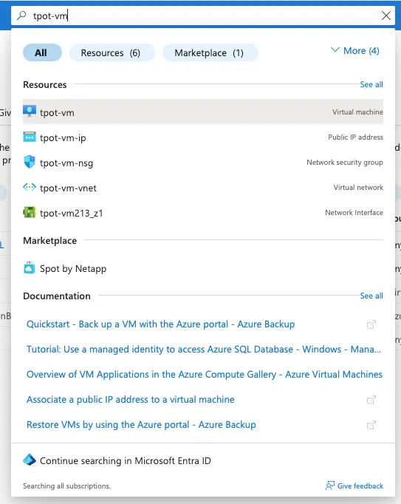
* **Figure 3–1** Go to the tpot-vm resource
* Copy the Public IP address to the clipboard

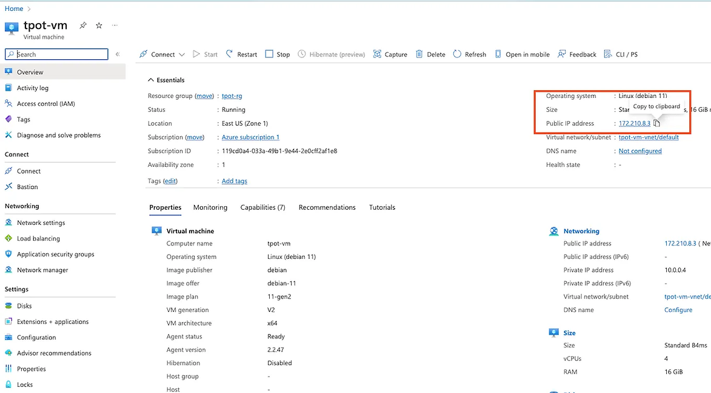

* **Figure 3–2** copy the Public IP address
* Windows now has the ability to SSH from the command prompt in Win 10 and Win 11, Mac and Linux also allows SSH from the terminal. Go ahead and SSH into the host: